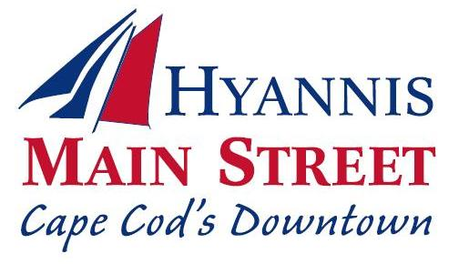

Board of Directors

David Colombo, Roadhouse Café, President
David Dumont, Dumont Enterprises, Vice President
Mark Sexton, Rockland Trust,
Clerk
Richard Penn, Puritan Cape Cod, Past President
Stanley Hodkinson, Cape Cod Five,
Treasurer
Betsy Young, SoHo Arts Company
Julie Kimball, Katie’s Ice Cream
Susan Ridgway, Cape Cod Times
David Lawler, Esquire
Sam Mazzeo, Palio Pizzeria
Jen Villa, Little Beach Gallery
Paul Marble, Sturgis Charter School
Caroline McKeon, Allium
Lynn Mitchell, Mrs. Mitchell’s Gifts
Aaron Webb, The Daily Paper

397 Main Street

Hyannis, MA 02601

Telephone (508) 775-7982

hyannismainstreet.com

HYANNIS MAIN STREET BUSINESS IMPROVEMENT DISTRICT NOTICE OF SPECIAL MEETING OF HMSBID MEMBERS

The Board of Directors of Hyannis Main Street Business Improvement District, Inc. has called a Special Meeting of HMSBID Members to be held:
Date: Tuesday, February 27, 2018
Time: 8:30-9:30 a.m.
Place: The Federated Church of Hyannis, 320 Main Street, Hyannis, (Baldwin Hall/back entrance)

The purposes of the meeting are:

1. To review the preceding five (5) years history of HMSBID
activities;
2. To review the update of the HMSBID Improvement Plan;
3. To consider whether to continue HMSBID for a five (5) year period commencing July 1, 2018; and
4. To solicit and discuss ideas and suggestions to add to the
HMSBID Improvement Plan.

Participating Members are eligible to vote if they are in financial good standing as of and including the November 1, 2017 billing from HMSBID at the time of the Meeting. Eligible Members may vote at the Meeting in person or by a proxy received by HMSBID at its office, 397 Main Street, 2nd Floor, Hyannis, MA 02601, prior to the commencement of the Meeting.

Please contact Elizabeth Wurfbain, Executive Director, by telephone (508) 775-7982, or by e-mail at
elizabeth@hyannismainstreet.com, regarding your attendance at the meeting.

